OŠ Spodnja Šiška DELO NA DOMU Učitelj: Majda Koudila
Sreda, 1.4..2020 6.a Učna snov: prepositions of place

1. Utrdi uporabo predlogov in preveri izgovorjavo. Poglej video Where is Chester (ime mačka)? in vadi izgovorjavo predlogov, tako da ponavljaš za govorcem..
https://www.youtube.com/watch?v=niPyVnC6W5g (2min)

2. V učbeniku Project 1, na strani 53 naredi vajo 3b Where is Edward? Za vsako sličico napiši eno poved.
Npr. Slika 1: Edward is under the bed.

3. Poglej sliko in izpolni vrzeli z IN, ON, UNDER, BEHIND, NEXT TO, BETWEEN, OPPOSITE. Poglej primer, ki je že rešen. Stavke prepiši v zvezek.
1- The cat is BETWEEN the chair and the small table.
2-The pencils are....................the glass
3- The school bag is .......................the table
4- The chair is .......................the bed
5- The trainers (športni copati) are...................the bed and the table.
6- The book is ..................the table.
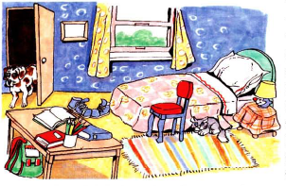
7- The rug is ......................the floor.
8- The dog is .....................the door.
9- The picture is .........................the window.
10- The small table is ....................the bed.
11- The big table is ....................the chair

