OŠ Spodnja Šiška DELO NA DOMU Učitelj: Majda Koudila
Ponedeljek, 20.4.2020 7.c Učna snov: Holiday postcard - stopnjevanje pridevnikov

1. Thomas piše prijatelju Stevenu s počitnic. V zvezek napiši manjkajoče besede (pridevniki v primerniku ali presežniku).
smaller ali the smallest?
Hi Steven,  I’m on holiday in Madeira but it’s a disaster! My hotel room is 1.……………...… (small) than the one in the photograph in the brochure. I think it’s 2.…………….…. (small) room in this hotel. The weather is terrible! It’s 3.…………..…………... (cold) than in England. The beach near the hotel is dirty It is 4.………..….. (dirty) of all the beaches on the island. The food is 5.……………..(expensive) than I expected so I don’t have enough money. But 6.……….………..… (bad) thing of all was when I lost my passport and my mobile phone. It is 7.……………..………….… (horrible) holiday in my life.  I want to come back as soon as possible.  Bye for now,  Thomas | 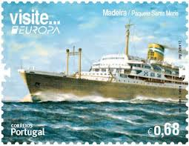  Steven Hazel  ________________  Rue du Cornet 8  ________________  B- 4800 Verviers  ________________  BELGIUM  ________________

2. Naredi vajo 4 na strani 63 v učbeniku.
Napiši kaj je zate najboljše in kaj najslabše. Za vsako stvar napiši v zvezek po dve povedi.
Primer:
I think the best school subject is English.
I think the worst school subject is Maths.
Naloge slikajte in mi jo pošljite na mail, da lahko vaše delo preverim.
majda.koudila@guest.arnes.si

