Ponedeljek, 23.3.2020 5.a

Utrjevanje 5. Lekcija Naloge lahko rešiš tukaj ali v zvezku.

Poglej in napiši. Primerjaj živali.
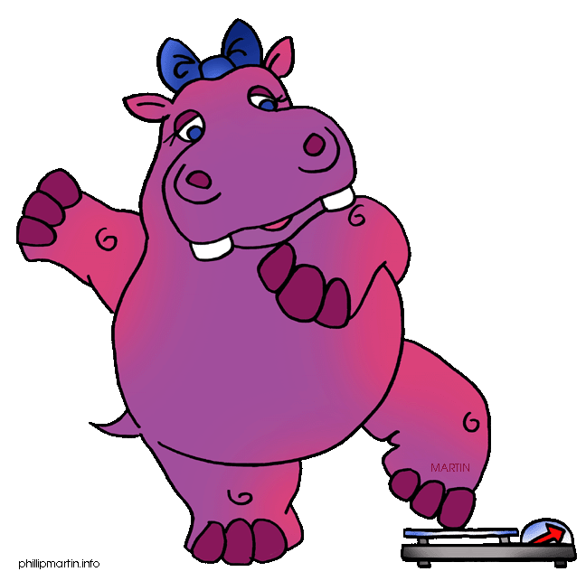 FAT 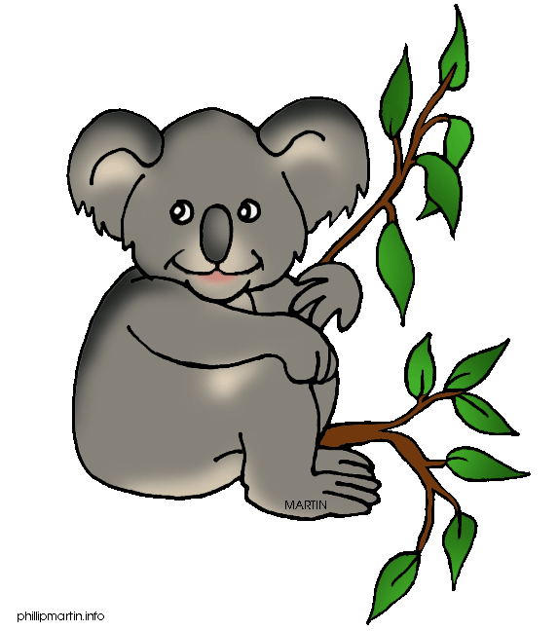
1. A hippo is ________than a koala.
SLOW 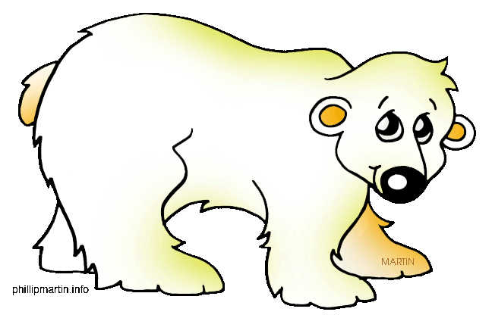
2. A________is________than a polar bear.

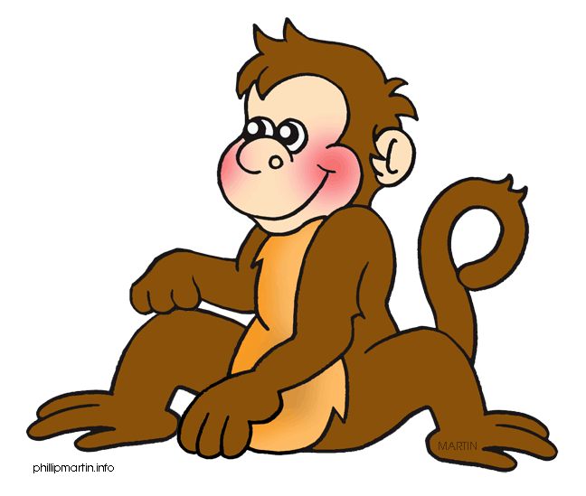 FUNNY 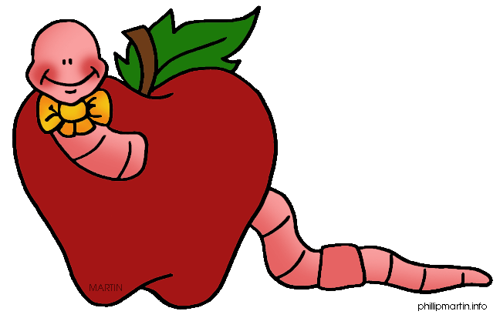
3. A ________is _________than a worm.
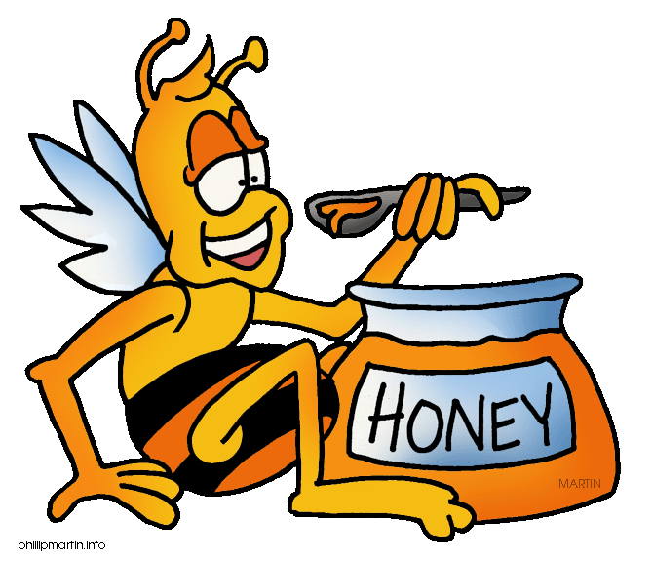 SMALL
4. A bee is ________ than a crocodile.
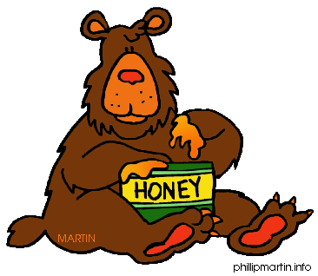 STRONG 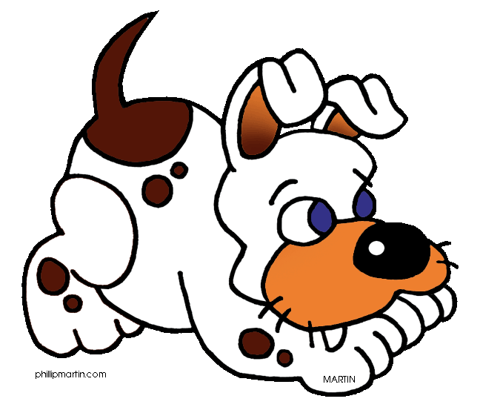

5. A bear is ________ than a ________
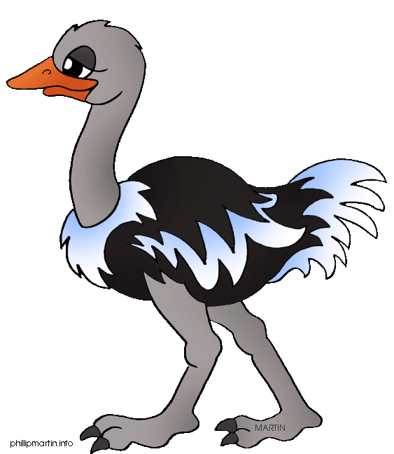 TALL 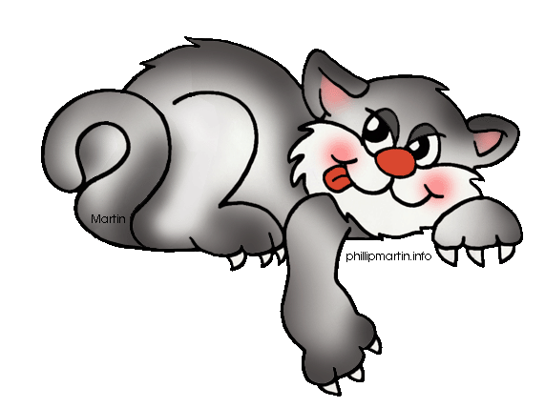
6. An ostrich is ________ than a ________.

POGLEJ IN NAPIŠI
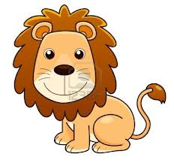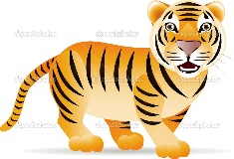(BIG) The tiger is bigger than the lion.______________
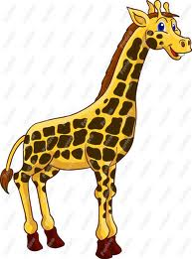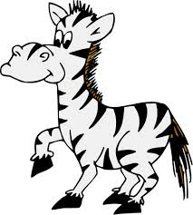(TALL) ___________________________________________________________________
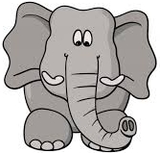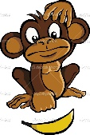 (FAT)____________________________________________________________________
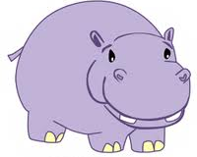(THIN)___________________________________________________________________
(SHORT)_______________________________________________________________
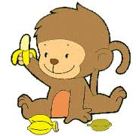(YOUNG)The baby monkey ____________________________________
______________________________________________________

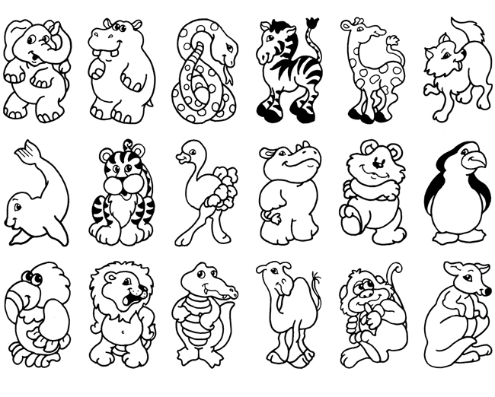
Izberi svojo najljubšo žival in napiši povedi s danimi pridevniki. Izberi 5.
BIG------------------SMALL FAST----------------SLOW
TALL----------------SHORT BEAUTIFUL--------UGLY
FRIENDLY---------DANGEROUS FAT-----------------THIN
LONG--------------SHORT

- An elephant is big, fat and beautiful.
- _____________________________________________________
_____________________________________________________
- _____________________________________________________
_____________________________________________________
- _____________________________________________________
_____________________________________________________
- _____________________________________________________
_____________________________________________________
- _____________________________________________________

