OŠ Spodnja Šiška DELO NA DOMU | Datum: sreda, 25.3.2020
Razred: 5.A | Učna snov: Revision unit 4 and 5
Učitelj: Majda Koudila

1. Naprej bomo pogledali rešitve.
Poglej in napiši. Primerjaj živali.
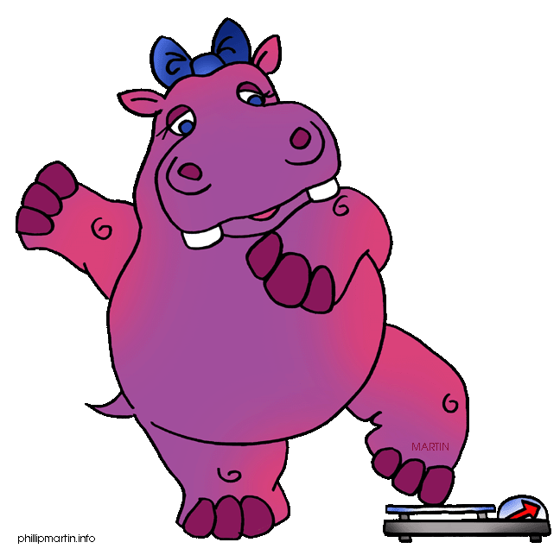 FAT 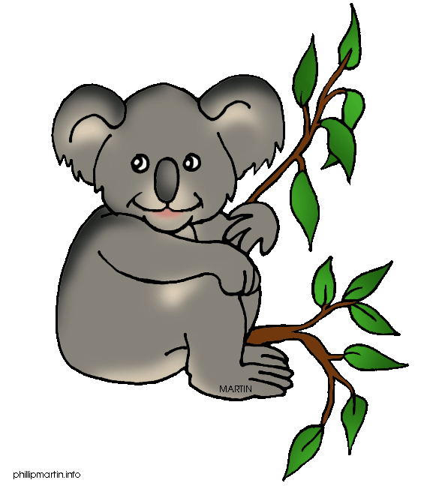
1. A hippo is FATTER than a koala.
SLOW 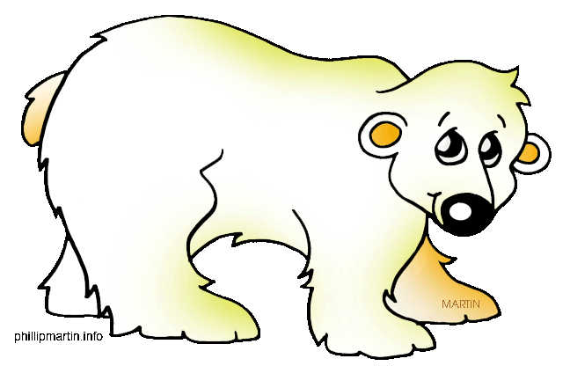
2. A KOALA is SLOWER than a polar bear.

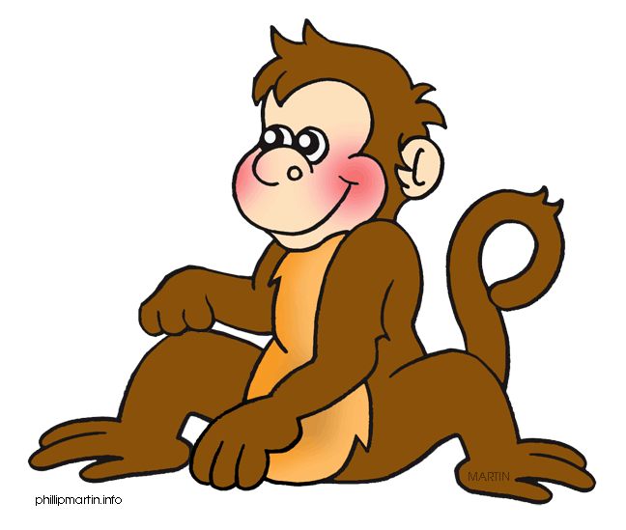 FUNNY 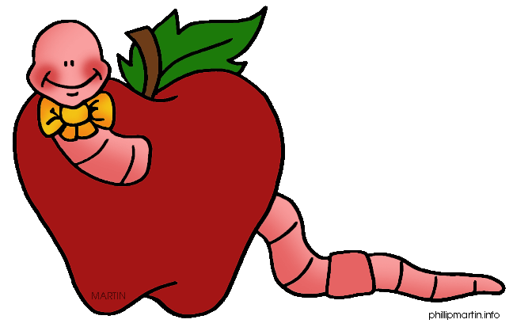
3. A MONKEY is FUNNIER than a worm.
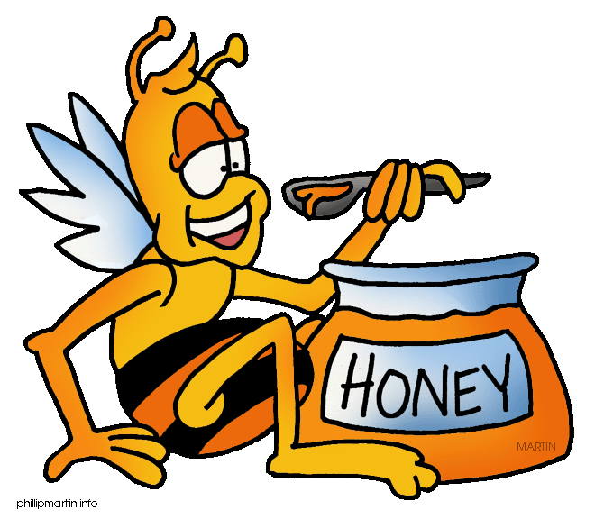 SMALL 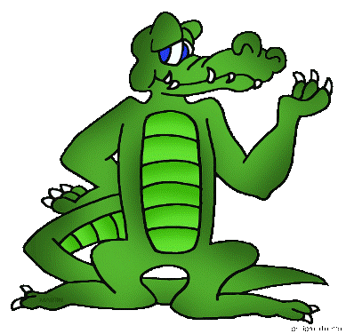
4. A bee is SMALLER than a crocodile.
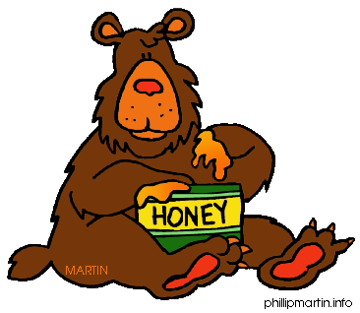 STRONG 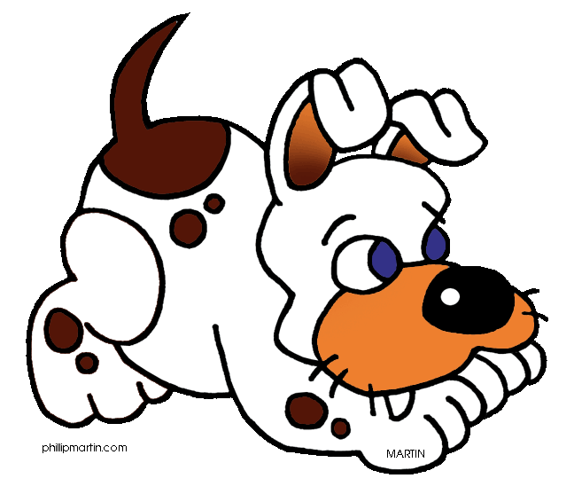

5. A bear is STRONGER than a DOG.
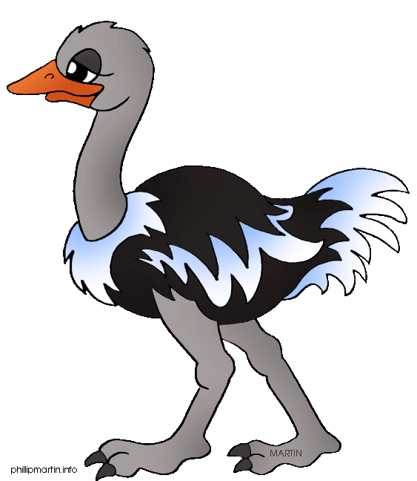 TALL 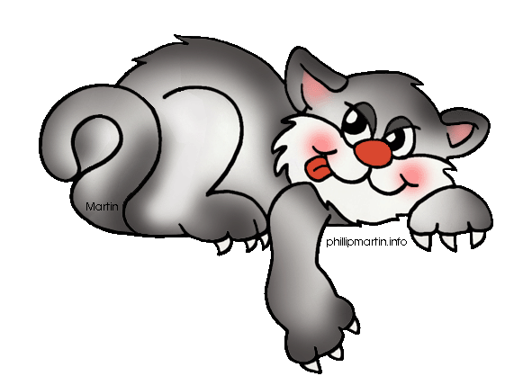
6. An ostrich is TALLER than a CAT.
POGLEJ IN NAPIŠI
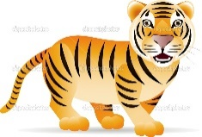(BIG) The tiger is bigger than the lion.______________
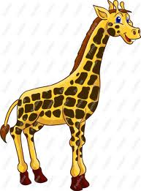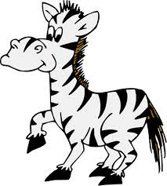(TALL) A giraffe is taller than a zebra.
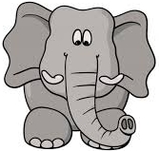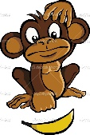 (FAT)An elephant fatter than a monkey.
(THIN)A hippo is thinner than a giraffe.
(SHORT)A lion is shorter than an elephant.
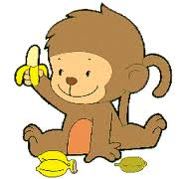(YOUNG)The baby monkey is younger than a lion.

Ponovitev učne snovi (unit 4 and 5)
1. Utrdi uporabo THERE IS / THERE ARE in sledeče povedi prepiši v zvezek, tako da jih dopolniš z THERE IS / THERE ARE.
Ne pozabi: THERE IS + A / AN + EDNINA
THERE ARE + MNOŽINA

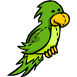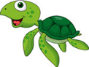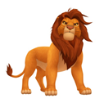
Dopolni there is ali there are.
- ___________________ two parrots.
- ___________________ a lion.
- ___________________ three turtles.
- ___________________ a hippo.
- ___________________ a mouse.
- ___________________ two rabbits.
- ___________________ a cat.

2. HOW DO YOU GO TO SCHOOL? (KAKO GREŠ V ŠOLO). Napiši kako greš TI v šolo. Napiši v zvezek.

Primer:
I go to school by bus.

1. 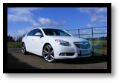
2. 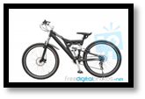
3.
4. 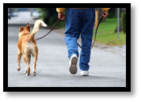

3. Utrdi uporabo predlogov in sledeče povedi prepiši v zvezek, tako da jih dopolniš z BETWEEN, NEXT TO, OPPOSITE.

Where is the………?
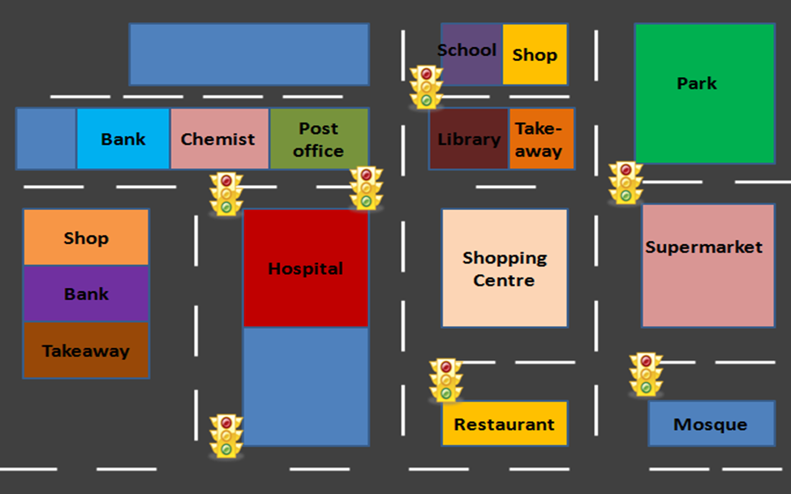

- The shop is _____________________ the school.
- The takeaway is _____________________ the library.
- The chemist is _____________________ the bank and the post office.
- The hospital is _____________________ the shopping centre.
- The bank is _____________________ the shop and the takeaway.
- The restaurant is _____________________ the shopping centre.

Prepiši v zvezek in dopolni povedi s pridevniki.
Sad – Big – Fat – Small – Happy - Thin

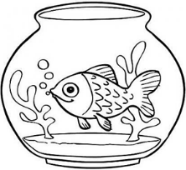 The fish is _____________

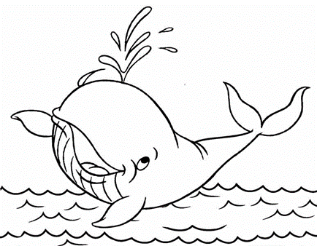 The whale is ___________

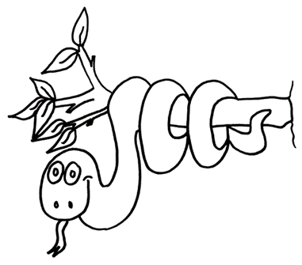 The snake is ___________
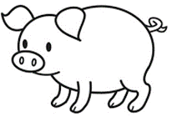 The pig is _____________
The dog is _____________
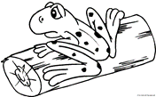 The frog is ____________

