Četrtek, 26.3.2020 6.a Učna snov: NPZ 2012 Bralno razumevanje in Raba jezika / Besedišče
Rešitve:
Str.50/1a Prepiši povedi in jih dopolni z eno od danih besed. Pazi na dodajanje črke S pri 'HE / SHE / IT'.
2. play
3. goes
4. work
5. goes
6. watch
7. does

Nato te stavke tudi zanikaj. Vse primere napiši v zvezek.
Npr. Mike hasn't got two brothers and a sister.
2. We don’t play basket ball at school
3. Sarah doesn’t go skiing in France.
4. We don’t work in a shop.
5. Mr West doesn’t go to work by car.
6. My parents don’t watch TV in the evening.
7. Mandy doesn’t do her homework in the kitchen.

2. PRESENT SIMPLE QUESTIONS
str.50/2. V zvezek napiši vprašanja. Npr. Are you from Austria?
Pazi na tvorbo vprašalne oblike z DO/DOES, HAVE GOT ali BE.
2. Is it my turn?
3. Do we have lunch at one o’clock?
4. Do they like football?
5. Am I in this photo?
6. Does Peter take the bus to school?
7. Have Mr and Mrs Johnson got a new computer?
8. Does Jane finish school at 3.15?
Rešitve:
3. Delovni zvezek, stran 41/nal. 4
2. When do you have dinner?
3. Jodie brushes her teeth every day.
4. Kati and Zoli have breakfast in the kitchen.
5. I go swimming after school.
6. What sports do you play?

4. Vprašaj po podčrtanih besedah. Vse povedi so v Present Simple Tense-u. Vprašanja zapiši v zvezek.
I like pop music. What do you like?

John’s uncle lives in New York.
Where does John’s uncle live?

Alan does his homework after school.
What does Alan do after school?

I have breakfast at school canteen.
Where do I/you have breakfast?

My sister wants a strawberry cake.
What does my sister want?

I speak English, Spanish and French.
What do I/you speak?

My father arrives home at 6.30 in the evening.
When does my father arrive home?

Tom meets his schoolfriends at the bus stop.
Who does Tom meet at the bus stop?

We play basketball on Sunday.
When do we/you play basketball?

Danes bomo spet malo vadili za NPZ oziroma bralno razumevanje in rabo besedišča. Naslednjo uro boste dobili rešitve in preverili, kako vam je šlo.
Naloge lahko tudi rešite za vikend če želite.
NPZ 2012

B) BRALNO RAZUMEVANJE
1. naloga Preberi besedilo, nato KRATKO odgovori na vprašanja. Glej primer 0, ki je že rešen.
ZULAA'S UNUSUAL HOBBY
Zulaa is a teenage girl who wants to become a good journalist when she grows up. If you ask 12-year-old Zulaa what she does before school, you might be surprised. Zulaa begins her day at a Mongolian public radio station as a volunteer correspondent. In this position, she makes a difference in the lives of the children throughout her country. Zulaa first got in touch with the public radio station in 2005 when a reporter interviewed her about her participation in the school's Olympiad contest. She liked it, so her father Shagdarsuren D., an important figure in radio broadcasting, encouraged her to start working for the radio station. Since 2006, Zulaa has hosted Good Morning, her own radio show for the children of Mongolia. Zulaa can be heard from 7:10 A.M. to 7:20 A.M., which is the time when children are awake and preparing for school. Topics for the show include: school events, contests, weather forecasts, daily horoscopes, advice on various topics, Mongolian news, and important world events. Zulaa works with the station's team. They help her with ideas for future radio shows. Zulaa also interviews people who have done interesting things or have important information to share related to the children's lives. “Since the show's content is related to my school, it's not that difficult to get material for my show,” Zulaa says. Both her home and the radio station are located in the capital of Mongolia. Because many people don't have access to television or daily newspapers, public radio is the usual way for Mongolians to connect to the world, especially for those who live in tents. Children can listen to Zulaa's radio show all over the country, including many who live in the countryside. She knows this because she receives poems, songs, and opinions on past shows from children throughout Mongolia. She keeps them all in big boxes at the radio station.

Primer: 0. How old is Zulaa? Twelve.
1. Where does Zulaa work before school? _______________________
2. When did Zulaa give her first interview for the public radio station? _______________________
3. What is the name of Zulaa's radio show? _______________________
4. Who helps Zulaa to plan radio shows? _______________________
5. How do most Mongolians get news? _______________________
6. Who writes to Zulaa? _______________________ 6

2. naloga Preberi besedilo in vsakemu odstavku poišči naslov, ki najbolje izraža njegovo vsebino. Črko izbranega naslova vpiši v razpredelnico. Dva naslova sta odveč. Glej primer 0, ki je že rešen.
BABY SEALS GROW UP ON THE ICE
0. In February, female seals know they are going to have a baby – a seal pup. They lift themselves up onto the sea ice and stay away from the other females. When seal pups are born they are 90 cm long and weigh 10 kg. Their fur is yellowish.
1. The mother seal smells her newborn pup so that she remembers it. She feeds it and then dives back into the sea. She watches it from a distance. When her baby calls, she knows its cry and comes out of the sea. She smells the pup so she knows it's the right one.
2. Seal pups drink milk 6 or 7 times a day so they put on more than 2 kg every day. By their third day, their fur is all white. This thick, curly coat keeps them warm but it's not waterproof. The pups can't go into the sea yet. If they feel they are in danger, they don't move.
3. Very young seal pups cry when they are hungry but eventually their mothers don't come back. Luckily, they don't die. They have a lot of fat in their bodies but they lose a lot of weight anyway. Their lovely fur starts to fall out.
4. In time, they meet other baby seals on the ice. They make little groups and move towards the sea ice. It's beginning to melt at this time of the year. The pups watch the water, but they keep away from it.
5. Sooner or later some of the young seals jump into the sea. The others follow and soon they are all swimming. They're only 3 weeks old at this point. For the next two months, they learn to dive. They catch small fish.
6. In early June, the young seals swim north. They will travel the same way as their parents. They head for the sea around Greenland. If they meet their mothers they won't recognise them. But before they set off, they must survive the hunters on the sea ice...
A What happens when mum goes forever?
B Taking care of a baby
C How do seal pups swim?
D Born on the ice
E Leaving their mums
F Swimming to a new place
G Starting to grow
H No family, but not alone I Learning new things
0 | 1 | 2 | 3 | 4 | 5 | 6
D

C) BESEDIŠČE
2. naloga Dopolni besedilo z besedami v okvirčku tako, da v razpredelnico vpišeš črko izbrane besede. Tri besede so odveč. Glej primer 0, ki je že rešen.
STUDENTS ARE FAMILY
A alone B biology C earns D high E meet
F nature G outside H owns I pupils J same
K thing L work
Solit Kim was born and raised in South Korea, and says that the most important __0__ in a Korean child's life is to learn in school and receive __1__ test results. All kids go to school all day and then they attend studying institutions after school for many hours. Solit says, “In the after school institutions we study what we are learning in school such as history, __2__, math, English, and Korean so that we can score high on our test scores in school. I want to go __3__ and play and have fun, but my parents, and all my friends' parents, force us to go to after school institutions. We are under a lot of pressure and stressed out, but I learn a lot and __4__ really good friends. My friends are my family. I stay with the __5__ kids from 7:30 in the morning until 11 o'clock at night. The teacher moves from room to room to teach the subjects, but we stay in the same room. There are usually 35 to 40 __6__ in each classroom.” Korean kids don't spend a lot of time with their families. In most homes, both the mom and dad __7__ while the children attend school and institutions. Solit's dad is an architect and her mom __8__ and operates a beauty shop. She has an older brother who she hardly knows because he attends other institutions.

0 | 1 | 2 | 3 | 4 | 5 | 6 | 7 | 8
K
1. naloga Oglej si sliko in dopolni besedilo z manjkajočimi besedami, ki se začenjajo z danimi črkami. Vsaka črtica predstavlja ENO ČRKO. Glej primer 0, ki je že rešen.

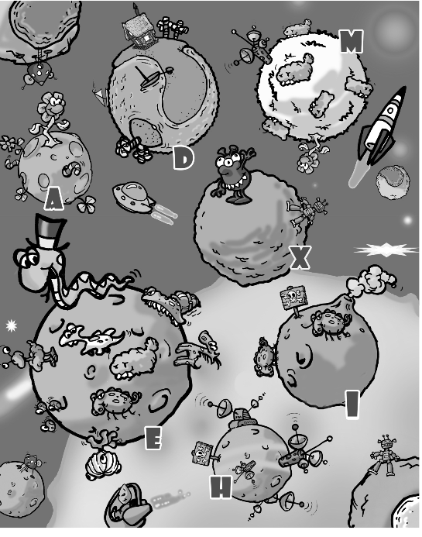

ABC GALAXY
Welcome to the ABC galaxy. The name of each (0)
p l a n e t is one of the 26 letters in the English alphabet. Each planet has something in common with another planet. Planet A, for example, has the same (1)f __ __ __ __ __ as planet M, which has the same radar as planet H. You can visit a three-eyed alien with two noses and sharp (2)t __ __ __ __ who lives on planet X. Planet E is the biggest zoo in the galaxy so only animals live on it. One of the residents is a giant snake wearing a (3)h __ __ on its head. Planets H and I have a danger sign, so it is not very safe to go there without a guide unless you are very brave and bold. There is a volcano on planet I and (4)s __ __ __ __ is coming out of it. Planet D is our tourists' favourite spot. There is a nice (5)h __ __ __ __ where you can stay during the holidays. It is located near the sea. The (6)w __ __ __ __ is clear and warm enough to go for a swim. If you want to know more about the ABC galaxy, give us a call or e-mail us at explorethegalaxy@space.jam. /6

